**Introduction**

This document serves as an user guide for the QuizServer C program. This Document also proposes a design for a Graphic User Interface for the client C program that would be compatible with the QuizServer Applciation.

**Design**

The user first connects to the server, and selects whether to join or create a group:

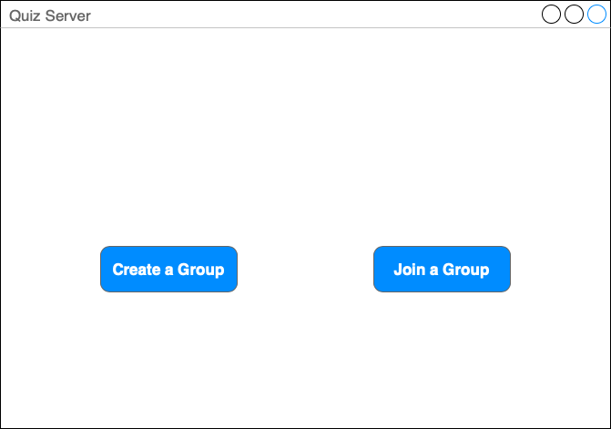

If the user selects to create a group, they most input the necessary group information (name, topic, quiz, and number of players):

Relevant Commands:

* GROUP|topic|groupname|groupsize
* QUIZ|quizsize|quiztext

If the user selects to join a group, they are able to select from a list of existing groups or search by group topic:

Relevant Commands:

* JOIN|groupname|username
* GETOPENGROUPS

Whilst the client is waiting for the activity to start, they’re able to cancel and go back to the Initial window to search for or a create new group. If the player who created the group cancels, an additional window will appear informing them that this will destroy the entire Group.

Relevant Commands:

* CANCEL|groupname
* LEAVE

Once the quiz has started, the user selects from 1 out of all the possible answers to a question. A correct answer results in the player gaining a point, whilst a wrong answer results in the player losing one. Alternatively, if no answer is selected their score remains unchanged.

Relevant Commands:

* ANS|answerID

After a question, the user receives a message of the player who answered the fastest. At the end of the quiz, a message is displayed containing the scores and names of each of the players. When the player close the window they are returned to the initial window where they’ll be able to search for or a create new group.

